ASSIGNMENT 2 (conditional and loops) MANEESH S SHETTY
- Write a Python program to find those numbers which are divisible by 7 and multiple of 5, between 1500 and 2700 (both included)
nl = []
for x in range(1500, 2701):
if (x % 7 == 0) and (x % 5 == 0):
nl.append(str(x))
print(','.join(nl))

2. Write a Python program that prints all the numbers from 0 to 6 except 3 and 6.
Note : Use 'continue' statement.
Expected Output : 0 1 2 4 5
for x in range(6):
if (x == 3 or x == 6):
continue
print(x, end=' ')
print("\n")
3. Write a Python program which iterates the integers from 1 to 50. For multiples of three print "Fizz" instead of the number and for the multiples of five print "Buzz". For numbers which are multiples of both three and five print "FizzBuzz".
fizzbuzz
1
2
fizz
4
Buzz
for fizzbuzz in range(51):
if fizzbuzz % 3 == 0 and fizzbuzz % 5 == 0:
print("fizzbuzz")
continue
elif fizzbuzz % 3 == 0:
print("fizz")
continue
elif fizzbuzz % 5 == 0:
print("buzz")
continue
print(fizzbuzz)
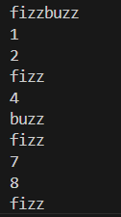

4. Write a Python program to check a triangle is equilateral, isosceles or scalene.
Note :
An equilateral triangle is a triangle in which all three sides are equal.
A scalene triangle is a triangle that has three unequal sides.
An isosceles triangle is a triangle with two equal sides.

print("Input lengths of the triangle sides: ")
x = int(input("x: "))
y = int(input("y: "))
z = int(input("z: "))
if x == y == z:
print("Equilateral triangle")
elif x == y or y == z or z == x:
print("Isosceles triangle")
else:
print("Scalene triangle")
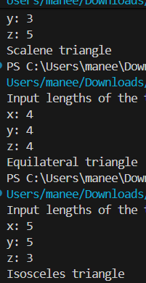
5. Write a Python program to calculate the sum and average of n integer numbers (input from the user). Input 0 to finish

print("Input some integers to calculate their sum and average. Input 0 to exit.")
count = 0
sum = 0.0
number = 1

while number != 0:
number = int(input(""))
sum = sum + number
count += 1
if count == 0:
print("Input some numbers")
else:
print("Average and Sum of the above numbers are: ", "average :",sum / (count-1),"SUM", sum)
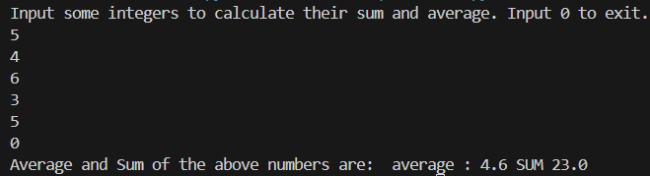
6. Write a Python program to construct the following pattern, using a nested loop number.
1
22
333
4444
55555
666666
7777777
88888888
999999999
for i in range(0,10):
print(str(i)*i)
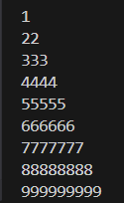
7. Write a Python program that counts the number of elements within a list that are greater than 30

def count_range_in_list(li, min):
ctr = 0
for x in li:
if min <= x :
ctr += 1
return ctr
list1 = [10, 20, 30, 40, 50, 60, 70, 80, 99]
print(count_range_in_list(list1, 30))

8. Take values of length and breadth of a rectangle from user and check if it is square or not
length =int(input("enter the length :"))
breadth =int(input("enter the breadth :"))
if length == breadth:
print("Square.")
else:
print("Not a Square.")
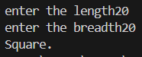
9. A shop will give discount of 10% if the cost of purchased quantity is more than 1000.
Ask user for quantity ,Suppose, one unit will cost 100. ,Judge and print total cost for user.

price=int(input("enter the price of the item: \n"))
quantity=int(input("enter the quantity of the item: \n"))
total=price*quantity
if (total>1000):
discount=total*0.1
final_price=total-discount
print("the original price is:",total)
print("the discounted price is: ",final_price)
else:
print("total price:",total)
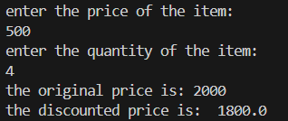
10) A company decided to give bonus of 5% to employee if his/her year of service is more than 5 years.
Ask user for their salary and year of service and print the net bonus amount.
salary = float(input("Enter your salary: "))
year_of_service = float(input("Enter years of service: "))
if year_of_service > 5:
bonus = 0.05 * salary
print("Congratulations! You are eligible for a 5% bonus.")
print("Net bonus amount:", bonus)
else:
print("No bonus. You need more than 5 years of service.")
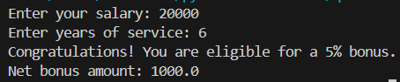

11. A school has following rules for grading system:
a. Below 25 - F
b. 25 to 45 - E
c. 45 to 50 - D
d. 50 to 60 - C
e. 60 to 80 - B
f. Above 80 - A
Ask user to enter marks and print the corresponding grade.
try:
marks = float(input("Enter the marks: "))

if marks < 25:
grade = "F"
elif 25 <= marks < 45:
grade = "E"
elif 45 <= marks < 50:
grade = "D"
elif 50 <= marks < 60:
grade = "C"
elif 60 <= marks < 80:
grade = "B"
else:
grade = "A"

print(f"Grade: {grade}")
except ValueError:
print("Please enter a valid numerical value for marks.")

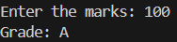

12. A student will not be allowed to sit in exam if his/her attendence is less than 75%.

held=int(input("enter the no. of classes held: \n"))
attended=int(input("enter the no. of classes attended: \n"))
attendance=(attended/held)*100
print("your attendance:",attendance,"%")
if (attendance>75):
print("you are allowed to write the exam")
else:
print("you are not allowed to write the exam")
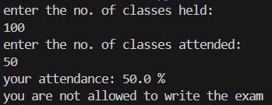

13. Take 10 integers from keyboard using loop and print their average value on the screen.

n=int(input("enter the number of value"))
val=[]
print(f"enter the {n} values")
for i in range(n):
a=int(input())
val.append(a)
print(val)
sum1=int(sum(val))
print(sum1)
avg=sum1/n
print(f"average of {n} numbers are :",avg)
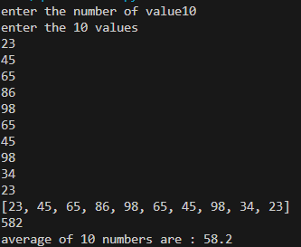

14. Print multiplication table of 24, 50 and 29 using loop.
def print_multiplication_table(number):
print(f"--- Multiplication Table of {number} ---")
for i in range(1, 11):
product = number * i
print(f"{number} * {i:2} = {product}")
print(" ENter a number to get the multiplication table")
num=int(input())
print_multiplication_table(num)
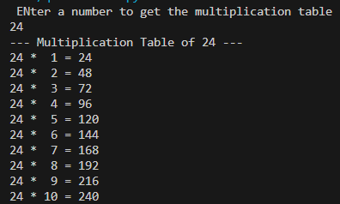

15. Take integer inputs from user until he/she presses q ( Ask to press q to quit after every integer input ). Print average and product of all numbers.

numbers = []
total_sum = 0
product = 1
while True:
user_input = input("Enter an integer (or 'q' to quit): ")
if user_input.lower() == 'q':
break
else:
try:
number = int(user_input)
numbers.append(number)
total_sum += number
product *= number
except ValueError:
print("Invalid input! Please enter a valid integer or 'q'.")
if numbers:
average = total_sum / len(numbers)
print("\n--- Results ---")
print(f"Numbers entered: {numbers}")
print(f"Average of all numbers: {average:.2f}")
print(f"Product of all numbers: {product}")
else:
print("\nNo numbers were entered.")

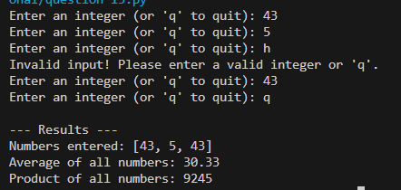

16. Take inputs from user to make a list. Again take one input from user and search it in the list and delete that element, if found. Iterate over list using for loop.
def main():
try:
n = int(input("How many items will the list have? "))
except ValueError:
print("Invalid number. Exiting.")
return

items = []
for i in range(1, n + 1):
items.append(input(f"Enter item {i}: "))

target = input("Enter the item to search and delete: ")

if target in items:
items.remove(target)
print(f"'{target}' found and deleted.")
else:
print(f"'{target}' not found in the list.")

print("Final list (iterated with a for loop):")
for it in items:
print(it)

if __name__ == '__main__':
main()
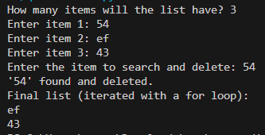
17. Using range(1,101), make three list, one containing all even numbers one containing all odd numbers One containing only prime numbers..
import math

def is_prime(n):
if n <= 1:
return False
for i in range(2, int(math.sqrt(n)) + 1):
if n % i == 0:
return False
return True
even_numbers = [x for x in range(1, 101) if x % 2 == 0]
odd_numbers = [x for x in range(1, 101) if x % 2 != 0]
prime_numbers = [x for x in range(1, 101) if is_prime(x)]
print("Even numbers:", even_numbers)
print("Odd numbers:", odd_numbers)
print("Prime numbers:", prime_numbers)

18. From the two list obtained in previous question, make new lists, containing only numbers which are divisible by 4, 6, 8, 10, 3, 5, 7 and 9 in separate lists.
even_numbers = [x for x in range(1, 101) if x % 2 == 0]
odd_numbers = [x for x in range(1, 101) if x % 2 != 0]
numbers = even_numbers + odd_numbers

divisors = [4, 6, 8, 10, 3, 5, 7, 9]

for d in divisors:
divisible = [x for x in numbers if x % d == 0]
print(f"Numbers divisible by {d}:", divisible)
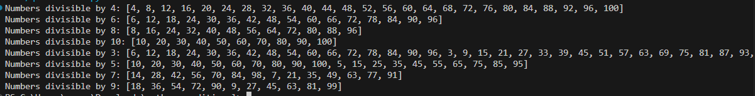
19. From a list containing ints, strings and floats, make three lists to store them separately
mixed = [1, 'apple', 2.5, 'banana', 3, 4.0, 'cherry', 7]
ints = [x for x in mixed if isinstance(x, int) ]
floats = [x for x in mixed if isinstance(x, float)]
strings = [x for x in mixed if isinstance(x, str)]

print("Original list:", mixed)
print("Integers:", ints)
print("Floats:", floats)
print("Strings:", strings)
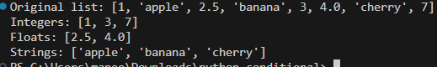
20.You are given with a list of integer elements. Make a new list which will store square of elements of previous list.
nums = [1, 2, 3, 4, 5]
squares = [x * x for x in nums]
print("Original list:", nums)
print("Squared list:", squares)
